**Experiment No: 11 Date:**

**OPEN SHORTEST PATH FIRST ROUTING**

**AIM:** Construct a network with at least 6 routers connected with a suitable topology where each network connected with 5 Pc’s. Implement OSPF (Open Shortest Path First) also known as Link State Routing.

**THEORY:**

**Introduction to Open Shortest Path First (OSPF) Routing:**

Open Shortest Path First (OSPF) is a dynamic routing protocol commonly used in computer networks to determine the best paths for data packets to traverse a network. It belongs to the category of link-state routing protocols, where routers exchange information about the state of their links with neighbouring routers to construct a complete network topology. OSPF then calculates the shortest path to each destination using Dijkstra's algorithm and updates its routing tables accordingly.

**Advantages of OSPF:**

1. **Fast Convergence:** OSPF reacts quickly to changes in network topology, as routers only need to update information about directly connected links rather than the entire network. This leads to faster convergence times compared to distance vector protocols like RIP.
2. **Scalability:** OSPF is highly scalable and suitable for large and complex networks. It can efficiently handle networks with hundreds or thousands of routers without significant performance degradation.
3. **Load Balancing:** OSPF supports equal-cost multipath (ECMP) routing, allowing routers to distribute traffic across multiple paths to a destination if they have the same cost. This enables effective load balancing and optimal resource utilization.
4. **Hierarchical Design:** OSPF can be configured with hierarchical network designs using areas, which partition the network into smaller domains. This enhances scalability and reduces the amount of routing information exchanged between routers.

**Disadvantages of OSPF:**

1. **Complexity:** OSPF configuration and management can be complex, especially in large networks with multiple areas. Network administrators require a deep understanding of OSPF concepts and careful planning to ensure optimal performance.
2. **Resource Consumption:** OSPF routers consume more memory and processing power compared to distance vector protocols, due to the need to maintain detailed link-state databases and calculate shortest paths.
3. **Convergence Issues in Large Networks:** While OSPF generally converges quickly, it may experience convergence issues in very large networks with frequent topology changes, leading to suboptimal routing and potential instability.

**Real-World Application of OSPF:**

OSPF is widely used in various real-world networking scenarios, including:

1. **Enterprise Networks:** OSPF is commonly deployed in enterprise networks, including corporate LANs and WANs, where scalability, fast convergence, and efficient routing are crucial.
2. **Service Provider Networks:** OSPF is also used by internet service providers (ISPs) and telecommunications companies to manage large-scale networks that provide connectivity to customers and support high-speed data transmission.
3. **Data Center Networks:** OSPF is utilized in data center environments to establish efficient communication between servers, switches, and other network devices. It helps optimize traffic flow and ensure high availability of services.

**Example:**

Consider a large university campus network divided into multiple areas using OSPF. Each area represents a different department, such as Engineering, Science, and Humanities. Routers within each area exchange link-state information to build a detailed network topology map. OSPF calculates the shortest paths from each router to destinations within and outside its area using Dijkstra's algorithm. As students and faculty members access resources located in different departments or external networks, OSPF dynamically updates routing tables to ensure optimal path selection and efficient data transmission.

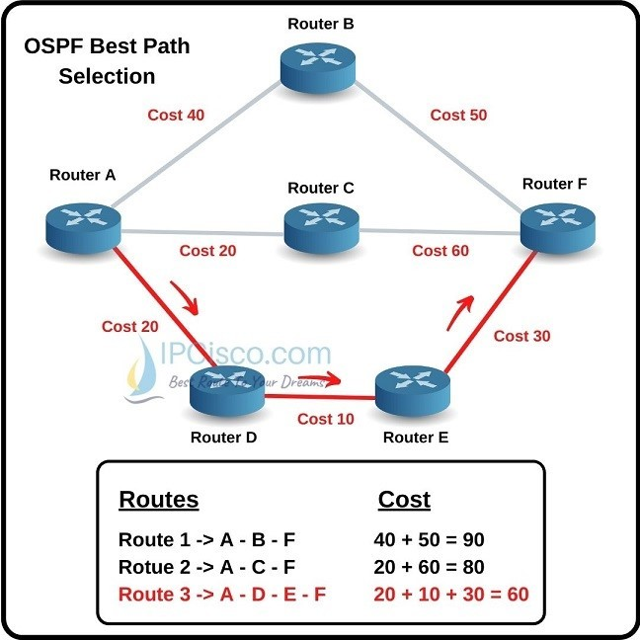

**Network Structure for Link State Routing Protocol**

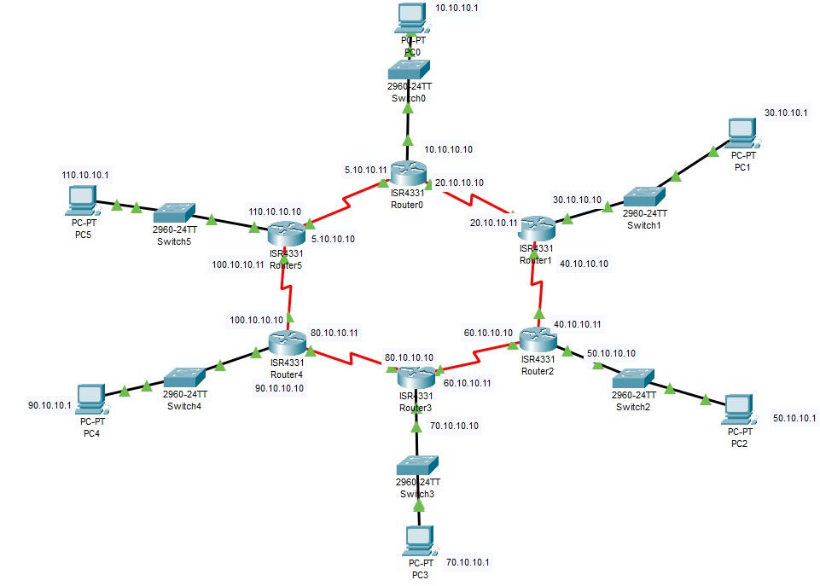

**Configuration of Router (Gigabit Port used For End Device)**

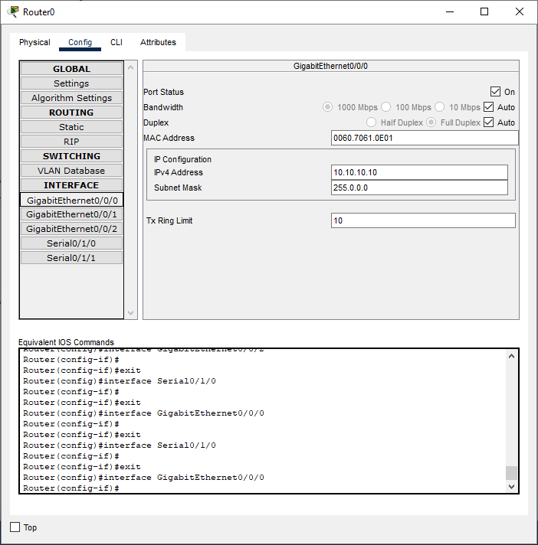

**Configuration of Router (Serial Port used for connecting with other routers)**

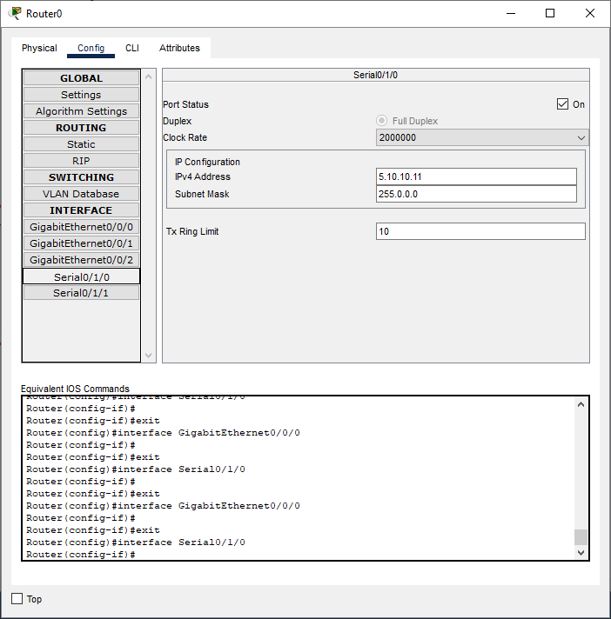

**Configuration of PC**

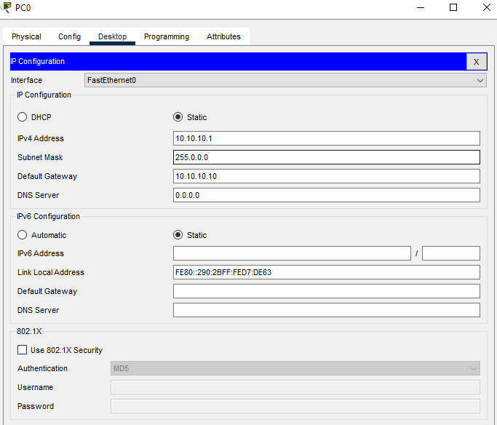

**Implementation of OSPF protocol on the Router**

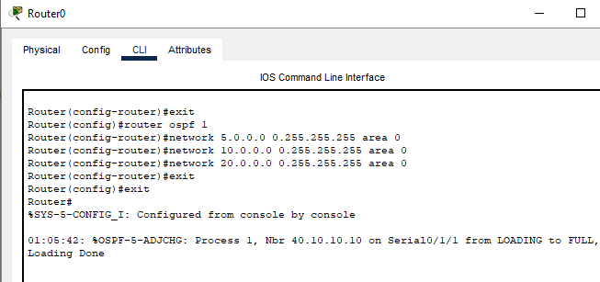

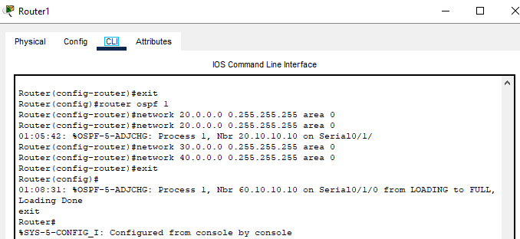

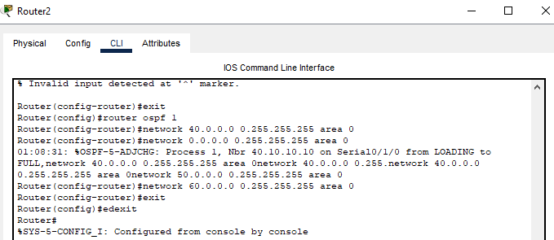

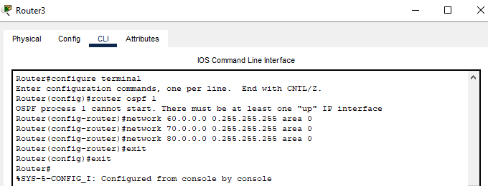

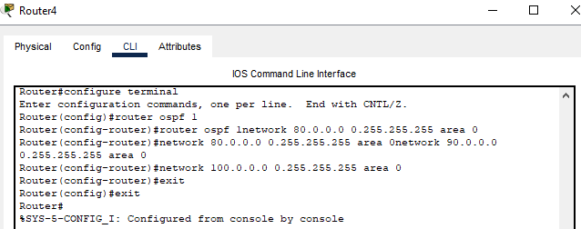

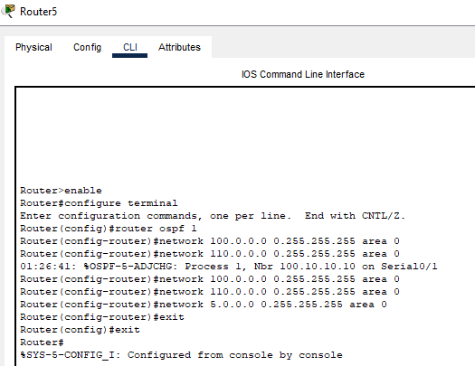

**Verification of Connectivity**

Sending a Simple PDU from PC 110.10.10.1 to PC 30.10.10.1

**Step1:**

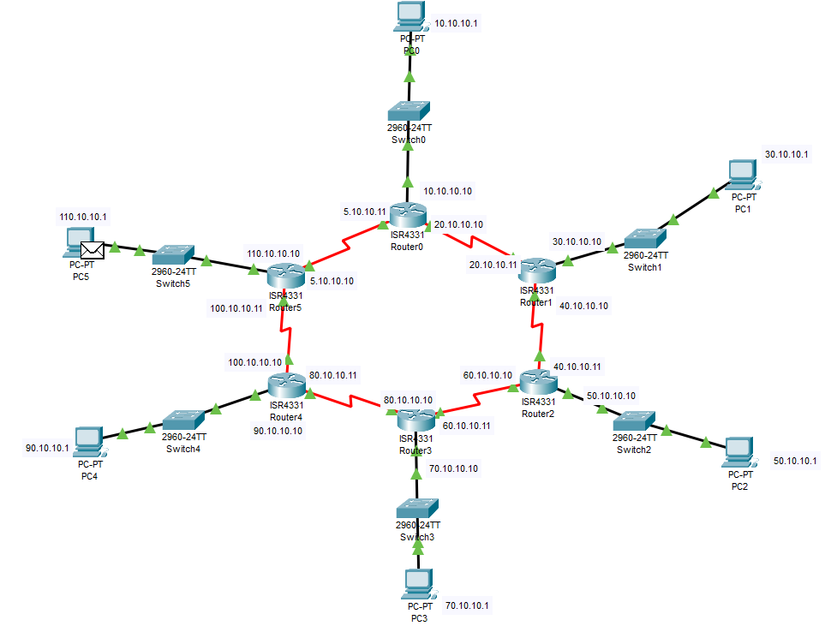

**Step2:**

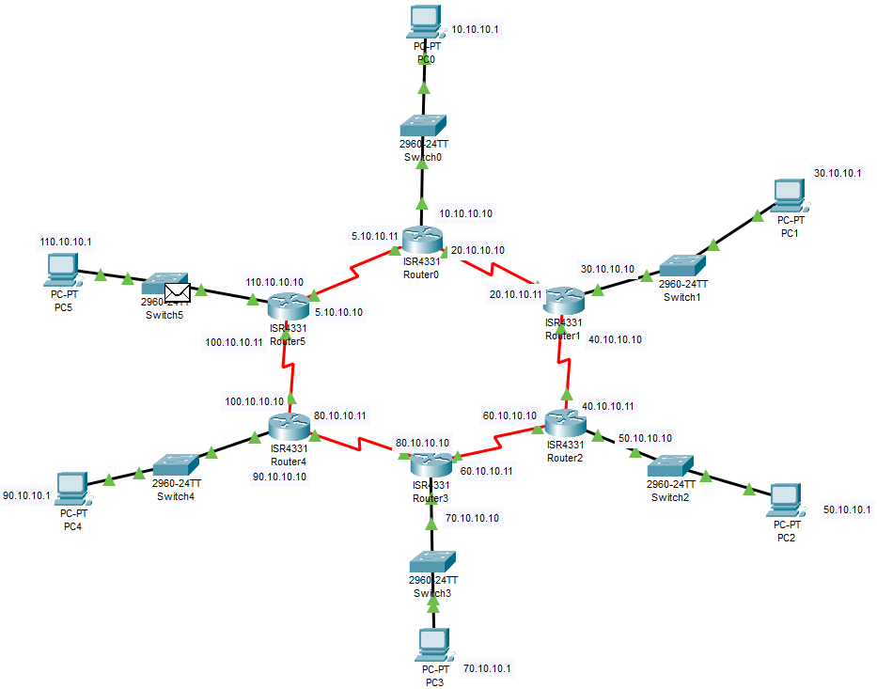

**Step3:**

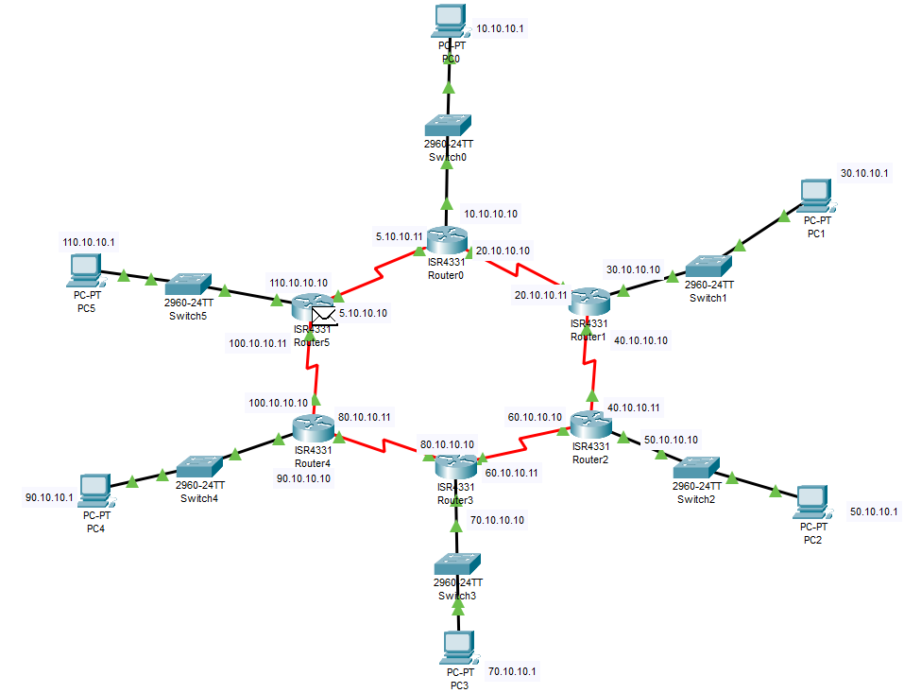

**Step4:**

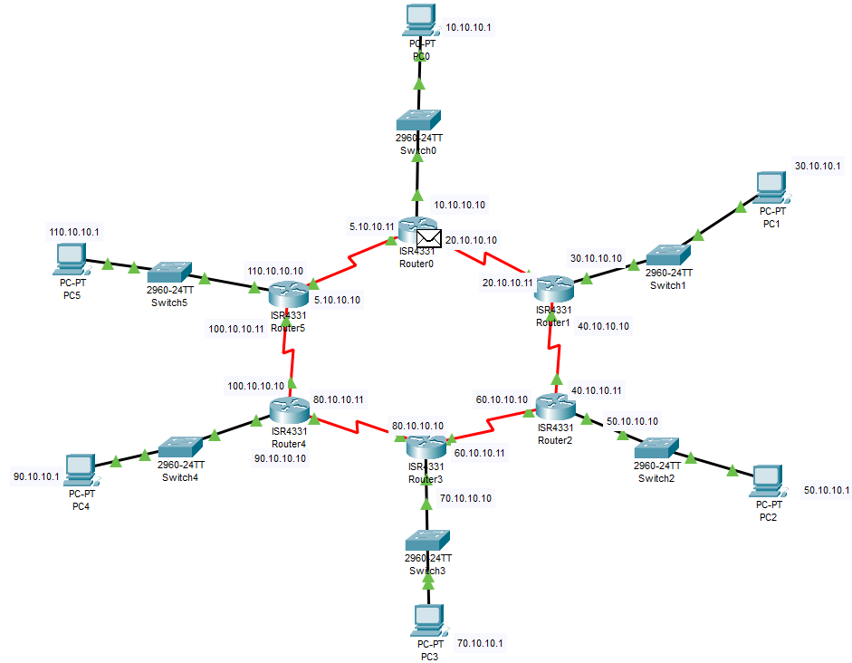

**Step5:**

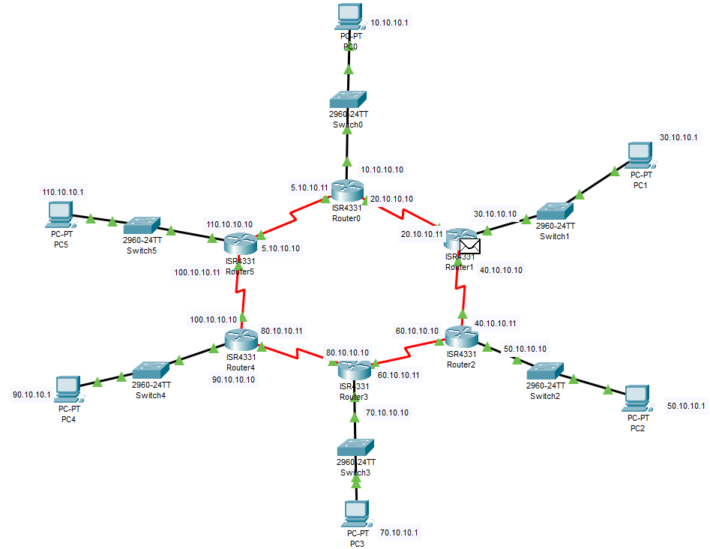

**Step6:**

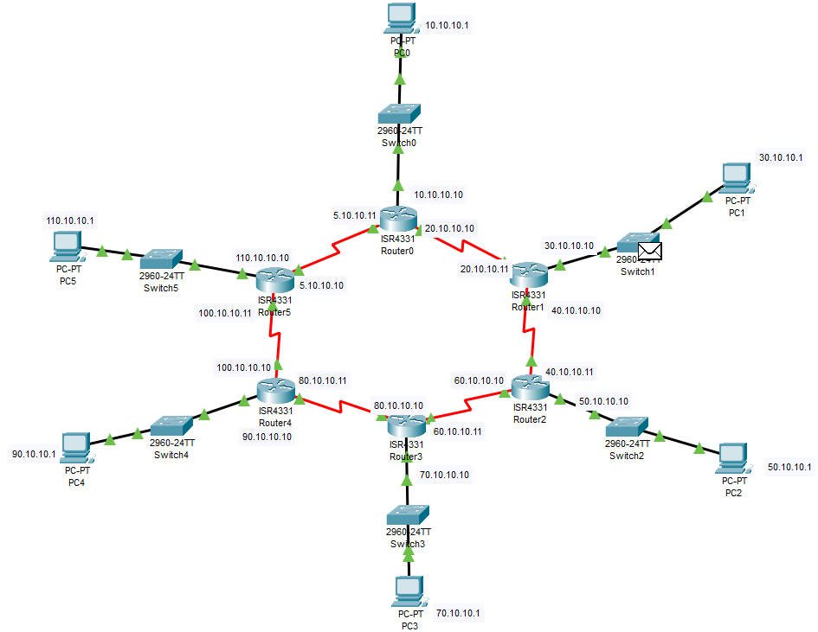

**Step7:**

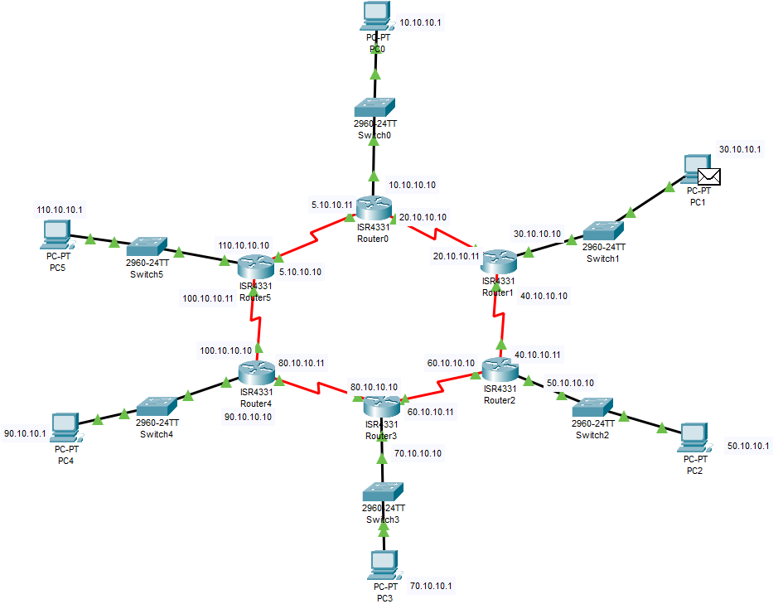

A Simple PDU was sent successfully from PC 110.10.10.1 to PC 30.10.10.1

**CONCLUSION:**

The Link State Routing Algorithm in networking also known as OSPF (Open Shortest Path First) was studied, created and verified successfully.